YLI TRIP 2022
PORTUGAL
DOURO RIVER CRUISE + LAND TOUR
CROISI EUROPE CRUISES aboard the MIGUEL TORGA
10 NIGHTS / 11 DAYS
SATURDAY, OCTOBER 15 – WEDNESDAY, OCTOBER 26, 2022
Starting at $3850 per person/double occupancy/Picture Window
$4250 per person/double occupancy/French Balcony
*Round Trip airfare is not included*

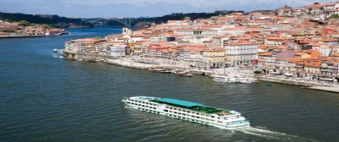
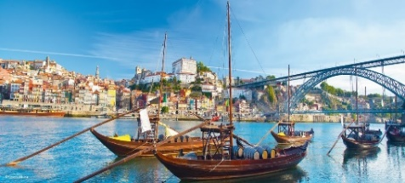
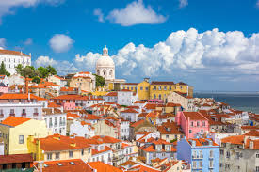
LISBON DOURO RIVER PORTO
PRE-CRUISE INCLUSIONS FOR LAND:
- Arriving transportation from Lisbon airport
- Hotel in Lisbon Nights 1-2
- Welcome dinner at hotel in Lisbon day 1
- Dinner nights 2-3
- Breakfast at hotel each day 2-4
- Lunch day 2-3
- Hotel in Fatima night 3
- Day tours day 1-4
- Transfers and sightseeing by motor coach per itinerary

CRUISE INCLUSIONS:
- 8 Days/7 Nights – double-occupancy cabin with private bath in stateroom
- All meals included – +DRINKS INCLUDED
- Refined French cuisine – Gala dinner and evening – Welcome Cocktail
- Free WI-FI in lounge and bar
- Excursion in each port
- Headsets are included for excursions
- Onboard activities and entertainment
- All port fees included
PRICE DOES NOT INCLUDE:
Drinks from their special menu, or drinks ordered during excursions, transfers, any meals not mentioned in the program, travel insurance and any personal expenses, tips, portage service. Other services not mentioned in the program.
For more information and to make a reservation, please contact:
Rhonda Kersting – Travel Advisor
rkersting@expediacruises.com
Mobile – 714-292-8251

CLIENT INFORMATION

First and Last Name(s): _______________________________________________________________
(Submit this booking form, photocopy of your passport with your $1000 deposit per person)

Dates of Birth: PAX 1) ___________________________ PAX 2) _____________________________
Home Phone Number: (_____) ______________________ Cell: (_____) _______________________
Email Address: _____________________________________________________________________
Mailing Address: ____________________________________________________________________
City: ___________________________ State _______________ Postal/Zip Code: ________________
Departing Airport ______________________ Airport Assistants: _______________________________
Special Air Requests: _________________________________________________________________
Dietary Needs: ______________________________________________________________________
Rooming with ______________________________________________________________________
Cabin type on Cruise ________________________________________________________________
Institute Name & Number_____________________________________________________________
Travel Insurance: Yes __ No __ If no, list reason for declining: _________________________________________________________________________________
Do you receive emails for Expedia Cruises? Yes __ No__. If no, may I have permission to enter you in my database? Yes __ No__

Emergency Contact: Name __________________________________Phone____________________
Note _____________________________________________________________________________
_________________________________________________________________________________

Rhonda Kersting
Travel Consultant
Email: rkersting@expediacruises.com
Mobile: (714) 292-8251
12982 Eveningside Drive
Santa Ana, Ca 92705

Make Check’s Payable to:
Orange County Cruises and Vacations

